Real-Time CommunicationSystem Powered by AI forSpecially Abled

**INTRODUCTION**

* 1. **Overview**

People get to know one another by sharing their ideas, thoughts, and experiences with those around them. There are numerous ways to accomplish this, the best of which is the gift of "Speech." Everyone can very convincingly transfer their thoughts and understand each other through speech. It will be unjust if we overlook those who are denied this priceless gift: the deaf and dumb. In such cases, the human hand has remained the preferred method of communication.

## Purpose

The project's purpose is to create a system that translates sign language into a human-understandable language so that ordinary people may understand it.

## LITERATURE SURVEY

* 1. **Existing problem**

### Some of the existing solutions for solving this problem are:

*Technology*

### One of the easiest ways to communicate is through technology such as a smart phone or laptop. A deaf person can type out what they want to say and a person who is blind or has low vision can use a screen reader to read the text out loud. A blind person can also use voice recognition software to convert what they are saying in to text so that a person who is Deaf can then read it.

*Interpreter*

### If a sign language interpreter is available, this facilitates easy communication if the person who is deaf is fluent in sign language. The deaf person and person who is blind can communicate with each other via the interpreter. The deaf person can use sign language and the interpreter can speak what has been said to the person who is blind and then translate anything spoken by the blind person into sign language for the deaf person.

*Just Speaking*

### Depending on the deaf person's level of hearing loss, they may be able to communicate with a blind person who is using speech. For example, a deaf person may have enough residual hearing (with or without the use of an assistive hearing device such as a hearing aid) to be able to decipher the speech of the person who is blind or has low vision. However, this is often not the most effective form of communication, as it is very dependent on the individual circumstances of both people and their environment (for example, some places may have too much background noise).

#### Proposed solution

This paper describes the system that overcomes the problem faced by the speech and hearing impaired. The objectives of the research are as follow:

* + 1. To design and develop a system which lowers the communication gap between speech- hearing impaired and normal world
    2. To build a communication system that enables communications between deaf-dumb person and a normal person.
    3. A convolution neural network is being used to develop a model that is trained on various hand movements. This model is used to create an app. This programme allows deaf and hard of hearing persons to communicate using signs that are then translated into human- readable text.

# THEORITICAL ANALYSIS

* 1. **Block diagram**

Architecture:

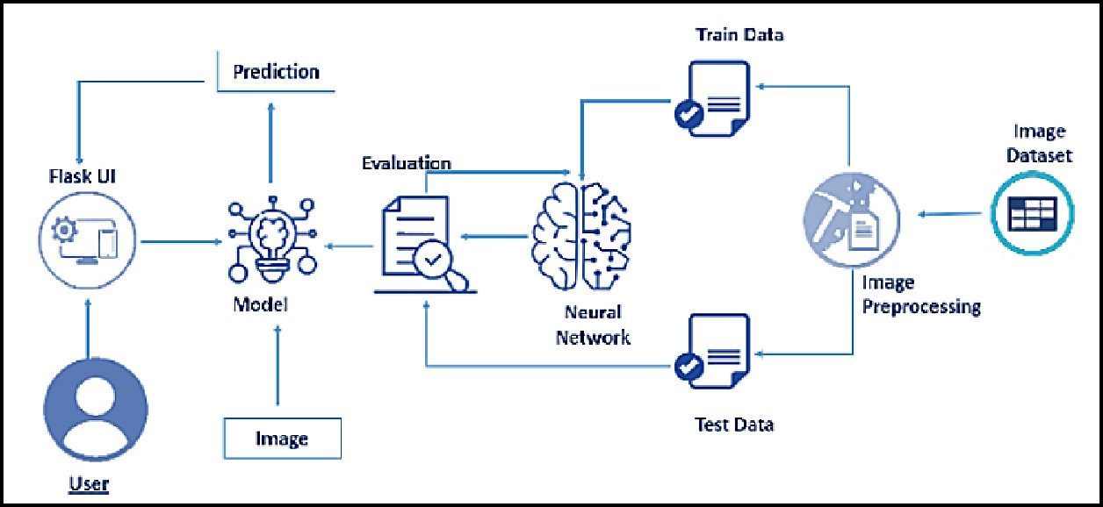

#### *3.1* Hardware / Software designing

##### Hardware Requirements:

|  |  |
| --- | --- |
| Operating System | Windows, Mac, Linux |
| CPU (for training) | Multi Core Processors (i3 or above/equivalent) |
| GPU (for training) | NVIDIA AI Capable / Google's TPU |
| WebCam | Integrated or External with FullHD Support |

**Software Requirements:**

|  |  |
| --- | --- |
| Python | v3.9.0 or Above |
| Python Packages | flask, tensorflow, opencv-python, keras, numpy,  pandas, virtualenv, pillow |
| Web Browser | Mozilla Firefox, Google Chrome or any modern  web browser |
| IBM Cloud (for training) | Watson Studio - Model Training & Deployment as Machine Learning Instance |

# EXPERIMENTAL INVESTIGATIONS

*Training and Testing using Dataset Provided:*

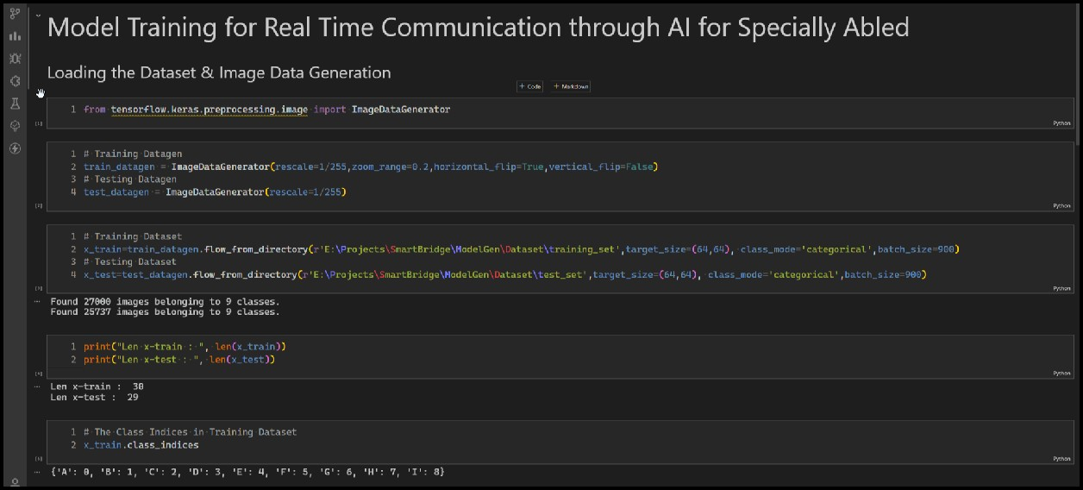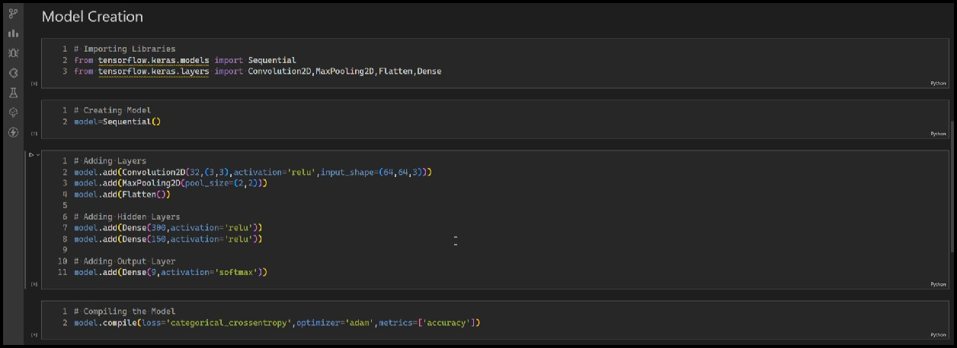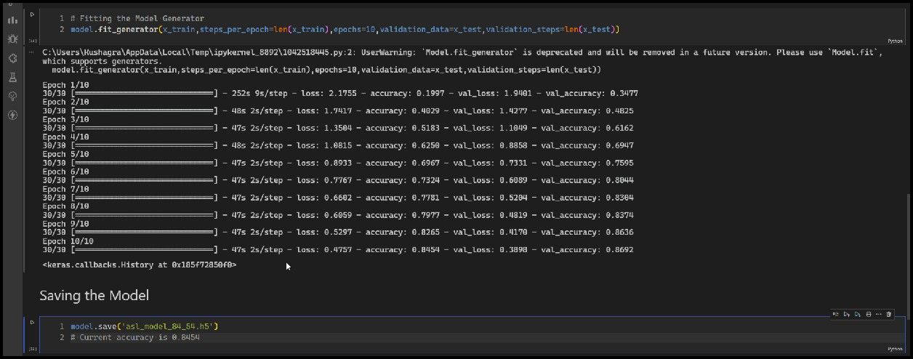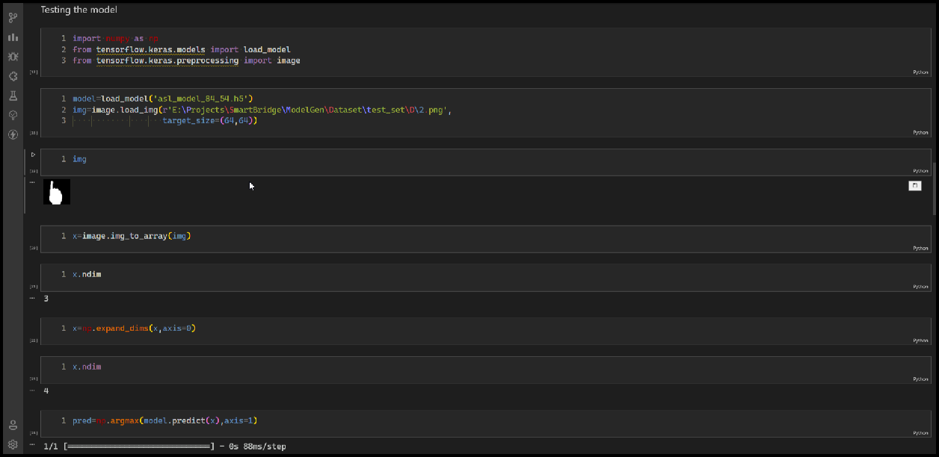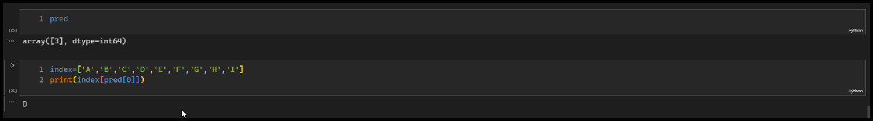

# FLOWCHART

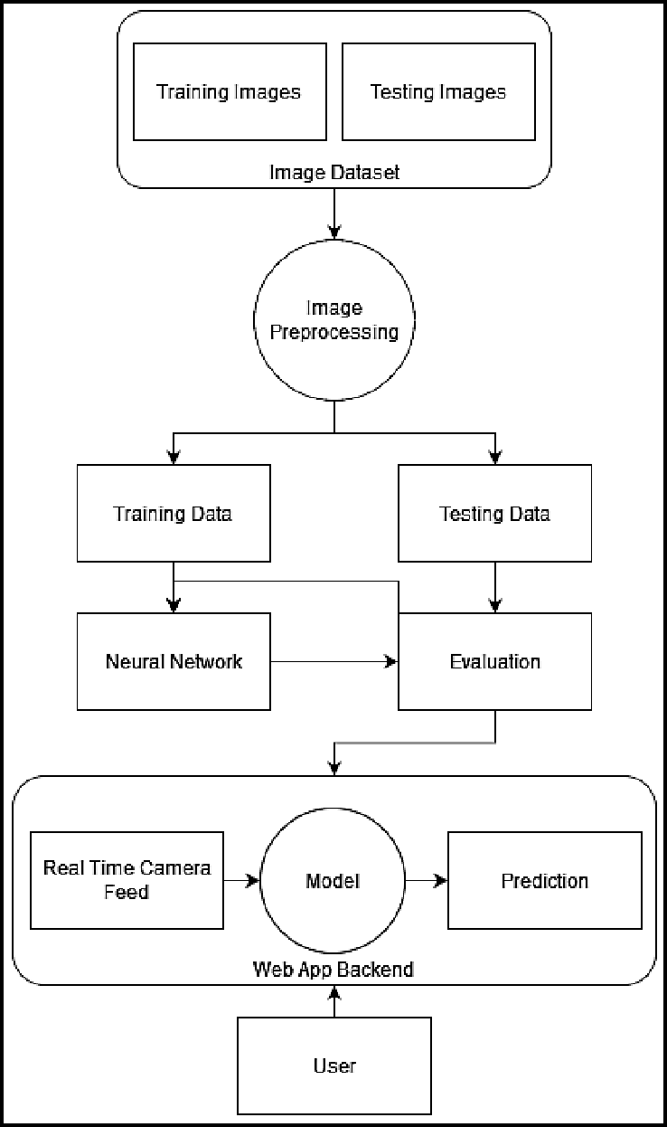

1. **RESULT**

The proposed procedure was implemented and tested with set of images. The set of 15750 images of Alphabets from “A” to “I” are used for training database and a set of 2250 images of Alphabets from “A” to “I” are used for testing database. Once the gesture is recognise the equivalent Alphabet is shown on the screen.

Some sample images of the output are provided below:

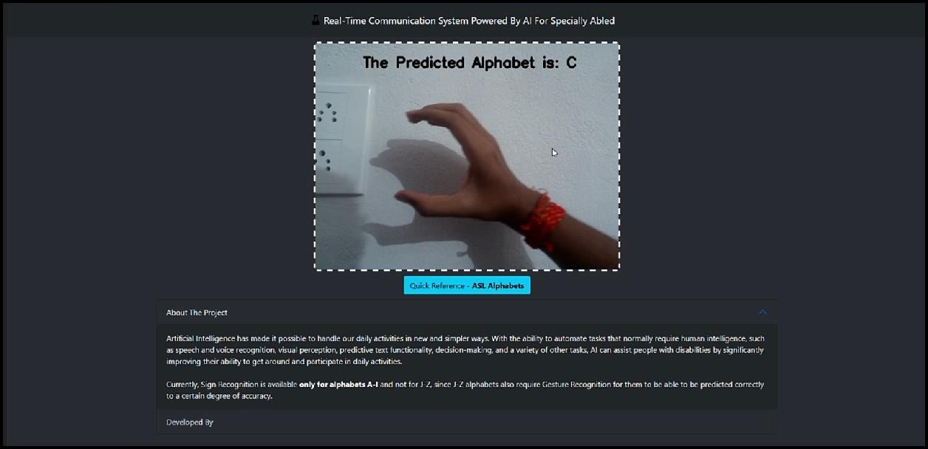

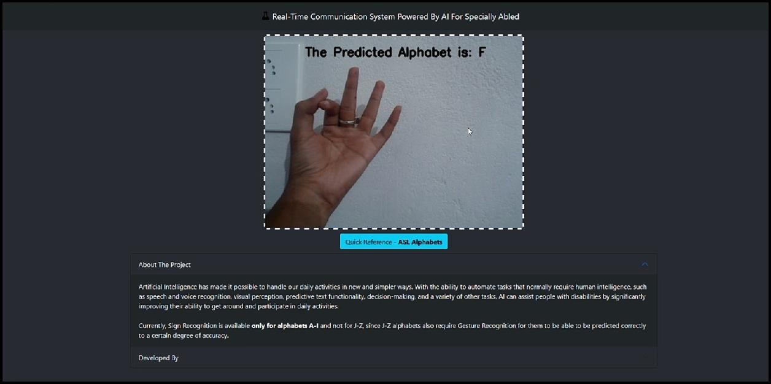

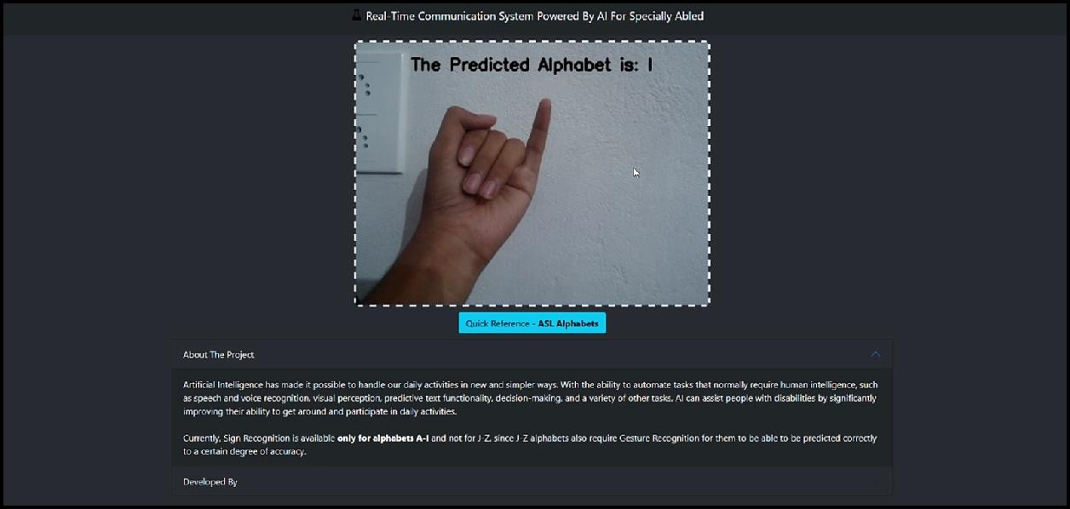

# ADVANTAGES & DISADVANTAGES

##### Advantages:

1. It is possible to create a mobile application to bridge the communication gap between deaf and dumb persons and the general public.
2. As different sign language standards exist, their dataset can be added, and the user can choose which sign language to read.

##### Disadvantages:

1. The current model only works from alphabets A to I.
2. In absence of gesture recognition, alphabets from J cannot be identified as they require some kind of gesture input from the user.
3. As the quantity/quality of images in the dataset is low, the accuracy is not great, but that can easily be improved by change in dataset.

# APPLICATIONS

1. It will contribute to the development of improved communication for the deafened. Themajority of people are unable to communicate via sign language, which creates a barrierto communication
2. As a result, others will be able to learn and comprehend sign language and communicatewith the deaf and dumb via the web app.
3. According to scientific research, learning sign language improves cognitive abilities, attention span, and creativity.

# CONCLUSION

Sign language is a useful tool for facilitating communication between deaf and hearing people. Because it allows for two-way communication, the system aims to bridge the communication gap between deaf people and the rest of society. The proposed methodology translates language into English alphabets that are understandable to humans.

This system sends hand gestures to the model, who recognises them and displays the equivalent Alphabet on the screen. Deaf-mute people can use their hands to perform sign language, which will then be converted into alphabets, thanks to this project.

# FUTURE SCOPE

Having a technology that can translate hand sign language to its corresponding alphabet is a game changer in the field of communication and Ai for the specially abled people such as deafand dumb. With introduction of gesture recognition, the web app can easily be expanded to recognize letters beyond 'I', digits and other symbols plus gesture recognition can also allow controlling of software/hardware interfaces.

# APPENDIX

*Source Code for Model Training and Saving:*

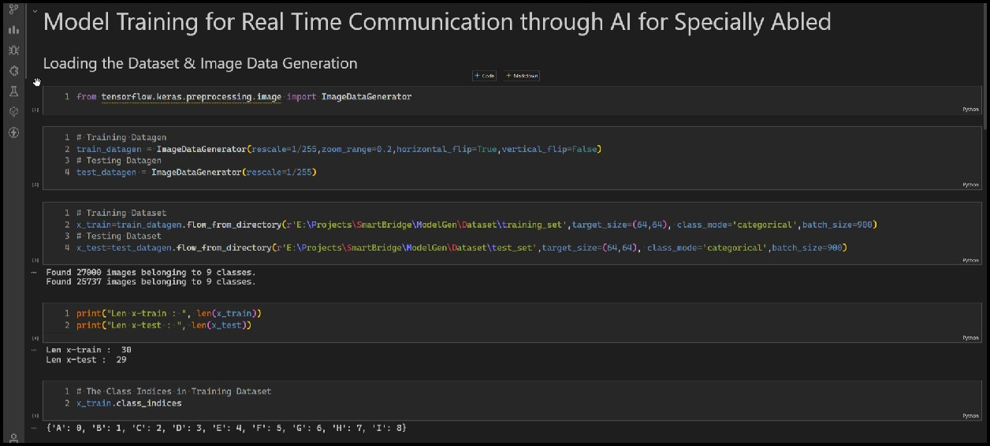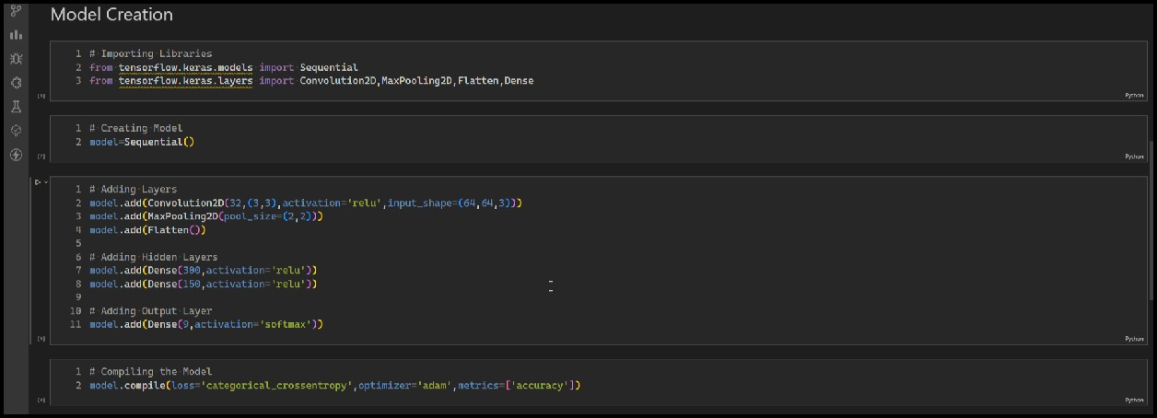

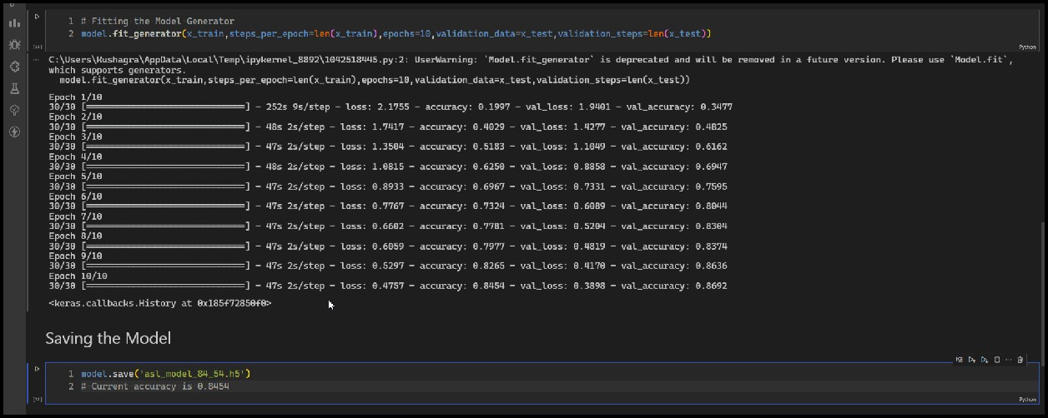

***IBM Model Training & Download Code:***

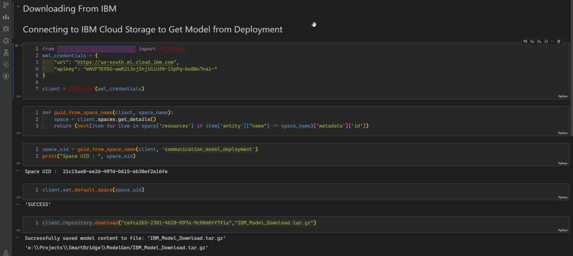

***Web app code:***

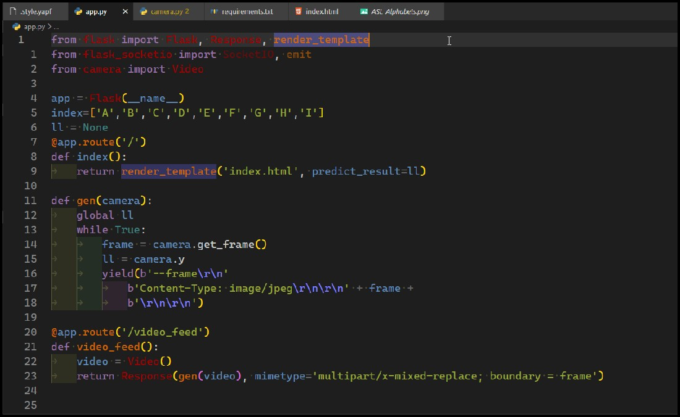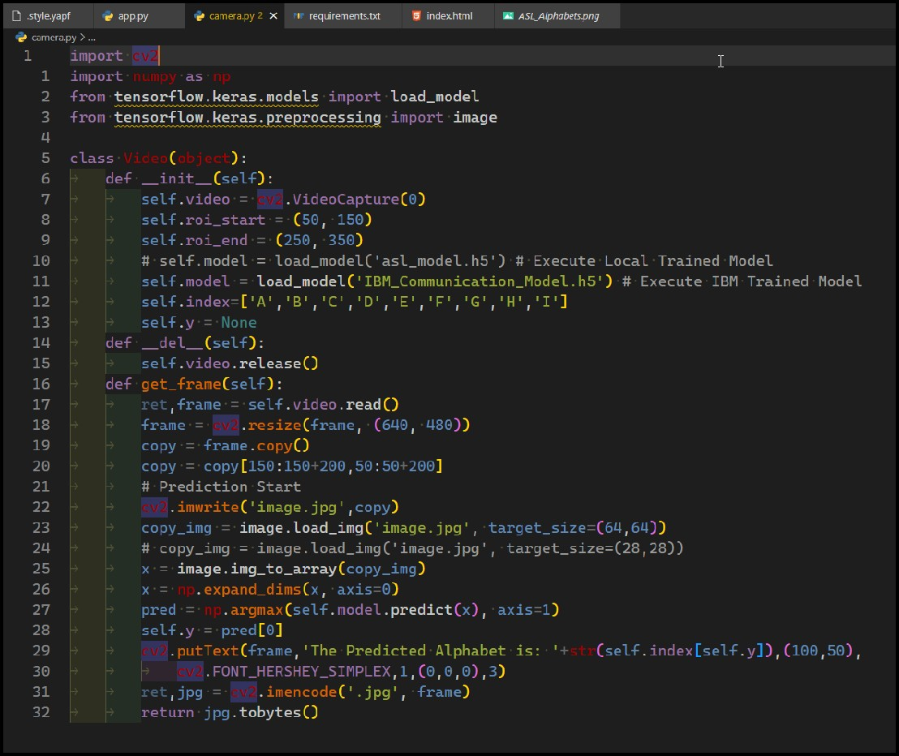

***American Sign Language Standard Reference:***

